**Statement 1:**

**Generate a random pair of 100 values. Apply the closest pair algorithm to find the closest pair**

**(distance). A C++ Implementation from scratch implementation with neat documentation is**

**expected.**

**EXPLATION:**

We have to divide points into two halves, after that smallest distance between two points is calculated in a recursive way. Using distances from the middle line, the points are separated into some strips. We will find the smallest distance from the strip array. At first two lists are created with data points, one list will hold points which are sorted on x values, another will hold data points, sorted on y values.

The time complexity of this algorithm will be O(n log n).

**CODING:**

#include <iostream>

#include <float.h>

#include <stdlib.h>

#include <math.h>

using namespace std;

// A structure to represent a Point in 2D plane

struct Point

{

    int x, y;

};

// Needed to sort array of points according to X coordinate

int compareX(const void* a, const void* b)

{

    Point *p1 = (Point *)a,  *p2 = (Point *)b;

    return (p1->x - p2->x);

}

// Needed to sort array of points according to Y coordinate

int compareY(const void* a, const void* b)

{

    Point *p1 = (Point *)a,   *p2 = (Point *)b;

    return (p1->y - p2->y);

}

// A utility function to find the distance between two points

float dist(Point p1, Point p2)

{

    return sqrt( (p1.x - p2.x)*(p1.x - p2.x) +

                 (p1.y - p2.y)*(p1.y - p2.y)

               );

}

// A Brute Force method to return the smallest distance between two points

// in P[] of size n

float bruteForce(Point P[], int n)

{

    float min = FLT_MAX;

    for (int i = 0; i < n; ++i)

        for (int j = i+1; j < n; ++j)

            if (dist(P[i], P[j]) < min)

                min = dist(P[i], P[j]);

    return min;

}

// A utility function to find a minimum of two float values

float min(float x, float y)

{

    return (x < y)? x : y;

}

// A utility function to find the distance between the closest points of

// strip of a given size. All points in strip[] are sorted according to

// y coordinate. They all have an upper bound on minimum distance as d.

// Note that this method seems to be a O(n^2) method, but it's a O(n)

// method as the inner loop runs at most 6 times

float stripClosest(Point strip[], int size, float d)

{

    float min = d;  // Initialize the minimum distance as d

    // Pick all points one by one and try the next points till the difference

    // between y coordinates is smaller than d.

    // This is a proven fact that this loop runs at most 6 times

    for (int i = 0; i < size; ++i)

        for (int j = i+1; j < size && (strip[j].y - strip[i].y) < min; ++j)

            if (dist(strip[i],strip[j]) < min)

                min = dist(strip[i], strip[j]);

    return min;

}

// A recursive function to find the smallest distance. The array Px contains

// all points sorted according to x coordinates and Py contains all points

// sorted according to y coordinates

float closestUtil(Point Px[], Point Py[], int n)

{

    // If there are 2 or 3 points, then use brute force

    if (n <= 3)

        return bruteForce(Px, n);

    // Find the middle point

    int mid = n/2;

    Point midPoint = Px[mid];

    // Divide points in y sorted array around the vertical line.

    // Assumption: All x coordinates are distinct.

    Point Pyl[mid];   // y sorted points on left of vertical line

    Point Pyr[n-mid];  // y sorted points on right of vertical line

    int li = 0, ri = 0;  // indexes of left and right subarrays

    for (int i = 0; i < n; i++)

    {

      if (Py[i].x <= midPoint.x && li<mid)

         Pyl[li++] = Py[i];

      else

         Pyr[ri++] = Py[i];

    }

    // Consider the vertical line passing through the middle point

    // calculate the smallest distance dl on left of middle point and

    // dr on right side

    float dl = closestUtil(Px, Pyl, mid);

    float dr = closestUtil(Px + mid, Pyr, n-mid);

    // Find the smaller of two distances

    float d = min(dl, dr);

    // Build an array strip[] that contains points close (closer than d)

    // to the line passing through the middle point

    Point strip[n];

    int j = 0;

    for (int i = 0; i < n; i++)

        if (abs(Py[i].x - midPoint.x) < d)

            strip[j] = Py[i], j++;

    // Find the closest points in strip.  Return the minimum of d and closest

    // distance is strip[]

    return stripClosest(strip, j, d);

}

// The main function that finds the smallest distance

// This method mainly uses closestUtil()

float closest(Point P[], int n)

{

    Point Px[n];

    Point Py[n];

    for (int i = 0; i < n; i++)

    {

        Px[i] = P[i];

        Py[i] = P[i];

    }

    qsort(Px, n, sizeof(Point), compareX);

    qsort(Py, n, sizeof(Point), compareY);

    // Use recursive function closestUtil() to find the smallest distance

    return closestUtil(Px, Py, n);

}

// Driver program to test above functions

int main()

{

    Point P[] = {{2, 3}, {12, 30}, {40, 50}, {5, 1}, {12, 10}, {3, 4},{10,2},{18,35},{78,65},{1,6}};

    int n = sizeof(P) / sizeof(P[0]);

    cout << "The smallest distance is " << closest(P, n);

    return 0;

}

**Output:**

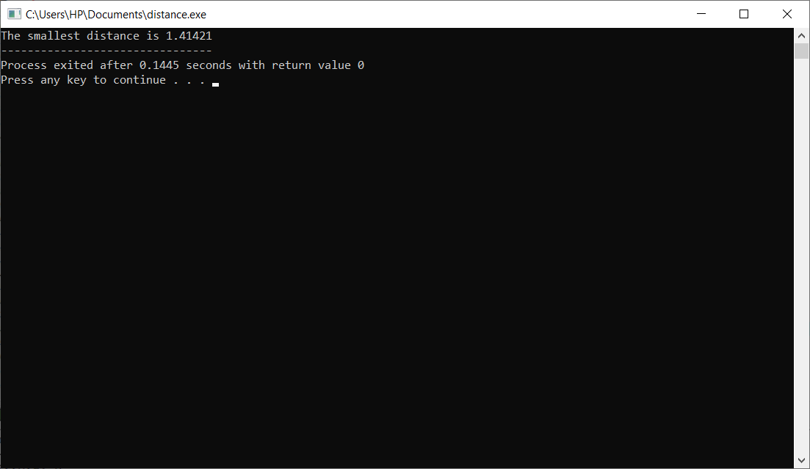

**Time Complexity:**

Let Time complexity of above algorithm be T(n). Let us assume that we use a O(nLogn) sorting algorithm. The above algorithm divides all points in two sets and recursively calls for two sets. After dividing, it finds the strip in O(n) time. Also, it takes O(n) time to divide the Py array around the mid vertical line. Finally finds the closest points in strip in O(n) time. So T(n) can be expressed as follows  
T(n) = 2T(n/2) + O(n) + O(n) + O(n)  
T(n) = 2T(n/2) + O(n)  
T(n) = T(nLogn)